Team Calendar Setup Guide

Overview

- Application deployment to your web server (not covered)
- Server application configuration
- Point client(s) to your web application url

Server application configuration
By default the application is configured to use demo / test data provider for calendar data.
This and other behavior is configured via application configuration file (web.config)
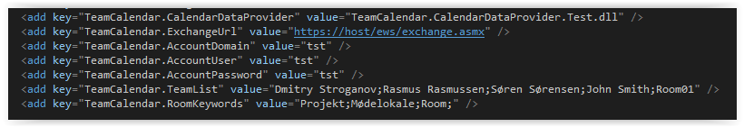

General configuration

TeamCalendar.DiagnisticMode
Enables or disables diagnostics logging (server log file).
Default: disabled
TeamCalendar.TeamList
Specifies list of semicolon (”;”) separated people / resources
Can be: AD user name, full name or email.

TeamCalendar.RoomKeywords

Specifies keywords distinguishing room resources used for grouping.

TeamCalendar.UICultureName
Specifies .Net UI culture
Default: "en-GB"
TeamCalendar.TimeZoneNumber
Specifies client Time Zone offset.
Default: 1

Calendar Data Provider configuration

Data providers are pluggable, and the application is loading the configured one from application bin folder.
TeamCalendar.CalendarDataProvider

Specifies data provider for the calendar.

MS Exchange calendar data provider: TeamCalendar.CalendarDataProvider.Exchange2010SP2

Default: TeamCalendar.CalendarDataProvider.Test, which is offline, read-only stub for demonstration / frontend test purposes.

TeamCalendar.CalendarUserDataResolver

Specifies data provider for resolving user names to emails and vice versa.
Can use MS Exchange or Active Directory (AD) to lookup the required user information.

MS Exchange provider name: TeamCalendar.CalendarDataProvider.Exchange2010SP2
AD provider name: TeamCalendar.Common. AdCommon

Default: TeamCalendar.CalendarDataProvider.Exchange2010SP2

TeamCalendar.ExchangeUrl
Specifies web service url of calendar data provider. E.g. MS Exchange web service url.
Example: https://[your_host_url]/ews/exchange.asmx
TeamCalendar.AccountUser
Specifies user name for accessing calendar data provider.
Required permissions: read-only access to view shared calendars.
TeamCalendar.AccountPassword
Specifies password for accessing calendar data provider.
TeamCalendar.AccountDomain
Specifies domain name for accessing calendar data provider.

Additional configuration / customization parameters

TeamCalendar.HoverBoxEnabled
TeamCalendar.HourNameBackColor
TeamCalendar.HourNameBorderColor
TeamCalendar.EventBorderColor
TeamCalendar.EventBackColor
TeamCalendar.EventBackColor_OOF
TeamCalendar.EventBackColor_Tentative
TeamCalendar.EventBackColor_Free
TeamCalendar.DurationBarVisible
TeamCalendar.HoverColor
TeamCalendar.BackgroundColor
TeamCalendar.BackgroundColorAlt
TeamCalendar.HeaderFontFamily
TeamCalendar.HeaderFontColor
TeamCalendar.HeaderFontSize
TeamCalendar.RoomHeaderFontColor
TeamCalendar.RoomHeaderHeaderFontSize
TeamCalendar.RoomHeaderBorderColor
TeamCalendar.HourFontFamily
TeamCalendar.HourFontSize
TeamCalendar.HourBorderColor
TeamCalendar.EventFontFamily
TeamCalendar.EventFontSize
TeamCalendar.NonBusinessBackColor
TeamCalendar.BorderColor
TeamCalendar.BusinessBeginsHour
TeamCalendar.BusinessEndsHour
TeamCalendar.Days
TeamCalendar.CellDuration
TeamCalendar.CellWidth
TeamCalendar.RowHeaderWidth
TeamCalendar.EventHeight
TeamCalendar.HeaderHeight
TeamCalendar.MaxEventTextLenght

Deployment scenarios

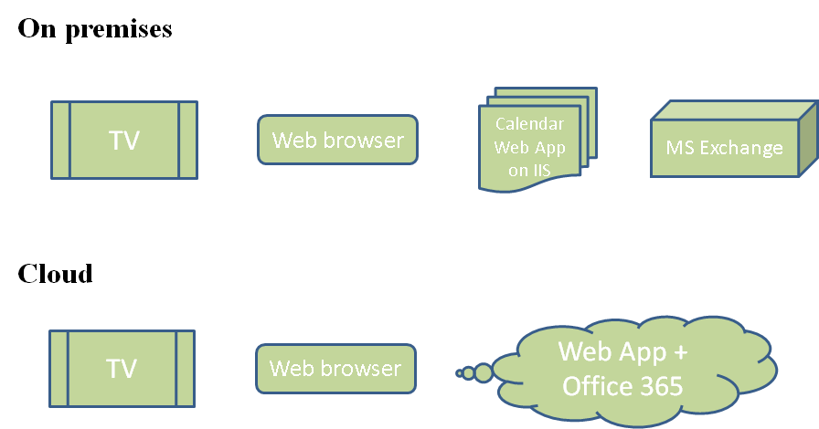

On premises

- IIS 6+ web server (virtual app per team)
- MS Exchange API access from the web server
- MS Exchange API service account
- IE/Chrome/FF client

Cloud
- Private url
- White label
- Access to enterprise Exchange API, or Office 365 Exchange API
- MS Exchange API service account
- IE/Chrome/FF client

